**Week-11-String Handling Functions**

**Reg no : 241001159**

**Name : PADaMAVATHY.M**

**Q1)**

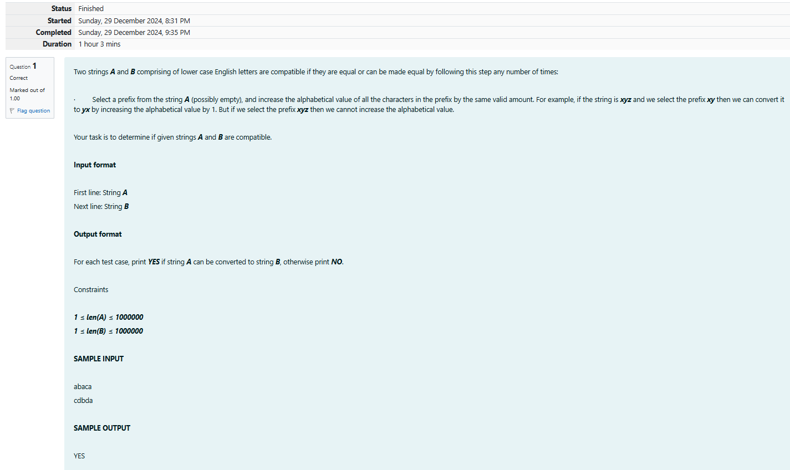

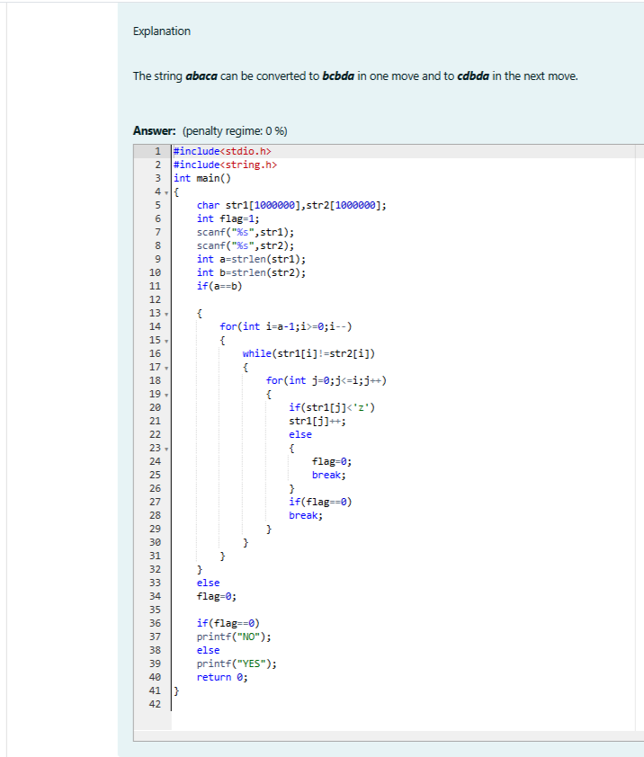

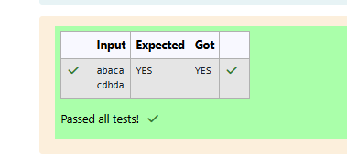

**Name :PADMAVATHY.M**

**ReG NO:241001159**

**Q2)**

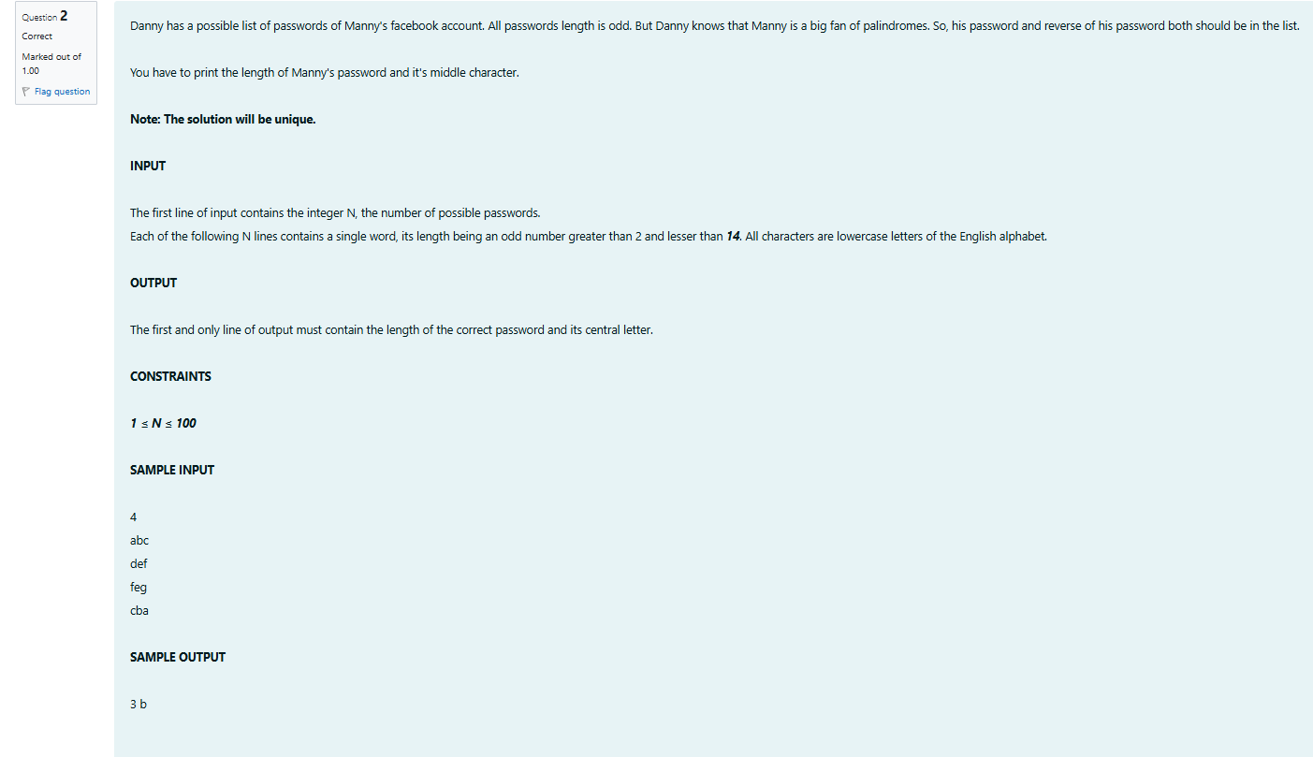

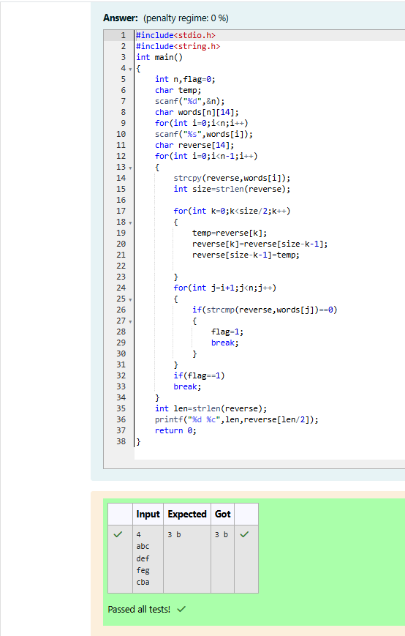

**Reg no : 241001159**

**Name : PADHMAVATHY.M**

**Q3)**

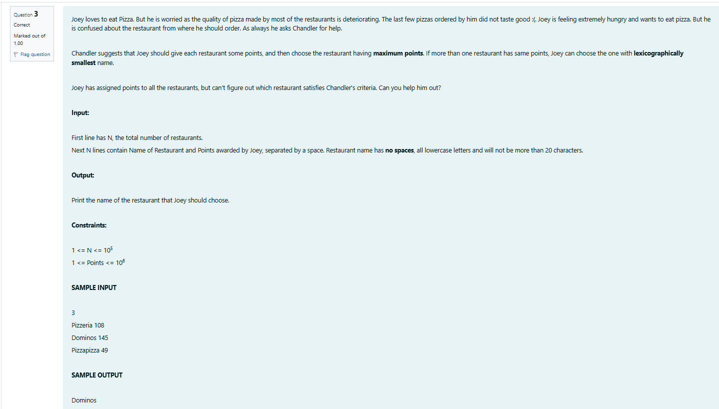

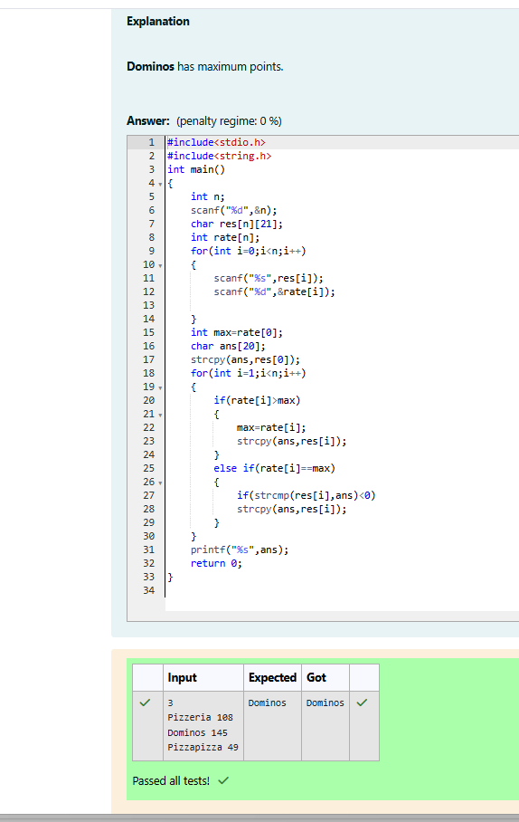

**Reg no : 241001159**

**Name : Padhmavathy.M**

**Q4)**

